11.06
Component Release
Process Design & AMOS Configuration Document
Purpose
This Process Design document is provided to Key-Users to record their key decisions regarding the AMOS Process design and the required AMOS configuration.
It is updated throughout the Project Definition Phase and used as the baseline for the Final Acceptance prior to Go-Live
Revision
Author, Name | Date | Notes
Marcel Moser | 01.06.2024 | First version

Table of Contents
1. Process Overview & Objectives 3
2. Regulatory References 3
3. Sections 145.Definitions & Glossary 3
4. Process Tasks 3
5. Process Dependencies 4
6. Process Flow 5
7. Process Design Questions 6
8. Data (Source) Mapping 7
9. Other Software Used 7
10. AMOS Configuration 8
a. Basic Data 8
b. Parameters 8
c. Workflows 8
d. Scheduled Tasks 8
e. API’s & Interfaces 9
11. Annex – Additional Info 9

Process Overview & Objectives

Process General Description:
To Certify / Re-Certify a component after removal or repair, both internal and external

Main Process Objective (Outputs & Outcomes):
This process covers the elements in AMOS associated with the release of parts back into a serviceable condition.
It is primarily driven by the performance of maintenance on components, by means of Component Workpackages, as well re-certification actions performed via the EPS module in AMOS (APN 326)

In addition, every certificate generated by AMOS can be further managed through the Certificate Management (APN 2740) module.

Regulatory References

- EASA Part-M, Regulation (EC) No 2042/2003
- EASA Part-145, Section 145.A.50
- FAA 14 CFR 43.9

Sections 145.Definitions & Glossary

Keywords | Explanation
Release Rotable | This function is available from Component Booking (APN 3296) to re-certify “Removed Serviceable” Rotables
EPS | Electronic Pending Shelf

Process Tasks

Business Process Task / Actions / Activities:
- Blank Serviceable Labels and blank Certificates may be printed directly from AMOS. Blank Certificates can be printed in the program Print empty Release Certificate (APN235). This process should be only used in exceptional situations when AMOS is not used in real time.
- Removed as a serviceable component for "3rd Party only":
- “Release Rotable” process from Component Booking (APN 3296) e.g., Robbery process
- Robbery process "Re-certification after EPS process: “
- Release Rotable process from Electronic Pending Shelf (APN326)
- Form Configuration (APN1444) can be used to make Certificate Fields Mandatory and Validation Rules to control form logic.
- Versioning of Certificates can be done in Certificate Management (APN 2740) in the case that a certificate requires a correction.
- Certificates can be made manually in Certificate Management (APN 2740) in the case that a certificate needs to be created prior to Goods Receiving.

Process Dependencies

- 11.01 – Capability List: This process is responsible to define the certifying capabilities available in AMOS, which in turn will influence other processes, such as:
- 11.04 – Component Maintenance: All activities associated with the repair of components are covered by this process.
- 08.04 – Parts Removal and Installation: Process documenting the actions pertaining the removal – and installation of parts. This is a key part of for the Component Release process.

Process Flow
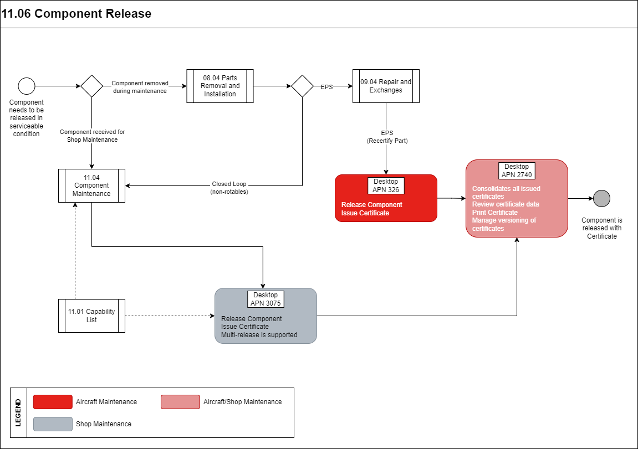

Process Design Questions

# | Question | Answer
1 | Who within the company has authority to certify/re-certify Rotables? For which cases.  - Removed as Serviceable?  - Out of a CM-Shop repair?  - Within the “EPS” process?
2 | What Certificate and paperwork is used?  - Certificate (EASA Form 1, FAA 8130)?  - Internal only?  - Serviceable Label?
3 | Where are the original Part Certificates stored?  - Physically with the Parts?  - Separately archived?  - Only scanned versions?
4 | Will removal & Installations be recorded in real time (close to the event), or can this take several days?
5 | Can we print the release certificate via the hardcoded Form One or customizable report designer Form One
6 | Which number should be displayed in Block 3 Form Tracking Number (Parameter 1742)?

Data (Source) Mapping

Data Sources | Description | Volume / Manual / Automatic / Static / Dynamic

Other Software Used

Other Software | Used by: | Description

AMOS Configuration

Basic Data

Basic Data Table | Notes
Certificate multi-release options | This table contains the Multi-Release Options used in Release Certificate dialog, which is displayed when "Add" button is pressed in program Certificate Management (APN 2740).

Parameters

Parameter Code | Parameter Name | Notes
1143 | USE COMBINED (EASA) FORM1 & FAR Part 43 | This parameter enables the double release EASA / FAA Form1.
1154 | ALLOW MULTIPLE RELEASE CERTIFICATE PRINTING | This parameter defines if the reprint of the original Release Certificate (Form 1) is allowed or not.
1255 | USE RELEASE CERTIFICATE / FORM ONE | With the new Certificate logic is used, please define the used certificate types and reports within Basic Data Administration (APN: 18) and the Basic Table "Address Certificate Type".
1577 | Use new release certificate | None.
1742 | Automatic certificate from tracking number generation | You can enable the automatic generation of a unique form tracking number for certificate by setting the string value to “Y”
1817 | Certificate Form Tracking Number affixes | A Prefix and Suffix can be configured that can be used for the Form Tracking Number during the Certificate creation.

Workflows

Workflow Number | Workflow Name | Notes
611 | New Part Certification | Workflow which is triggered after whenever there is new active part certificate created.

Scheduled Tasks

Scheduled Task Reference | Frequency | Notes

API’s & Interfaces

Reference | Direction | Trigger | Frequency

Annex – Additional Info

N/A

